Project Design Phase-I
Solution Architecture

Date | 19 September 2026
Team ID | Individual
Project Name | EV Market Performance & Sustainability Analytics Dashboard
Maximum Marks | 4 Marks

Solution Architecture:
Solution architecture is a complex process – with many sub-processes – that bridges the gap between business problems and technology solutions. Its goals are to:
- Find the best tech solution to solve existing business problems.
- Describe the structure, characteristics, behavior, and other aspects of the software to project stakeholders.
- Define features, development phases, and solution requirements.
- Provide specifications according to which the solution is defined, managed, and delivered.

Sample Solution Architecture Diagram:
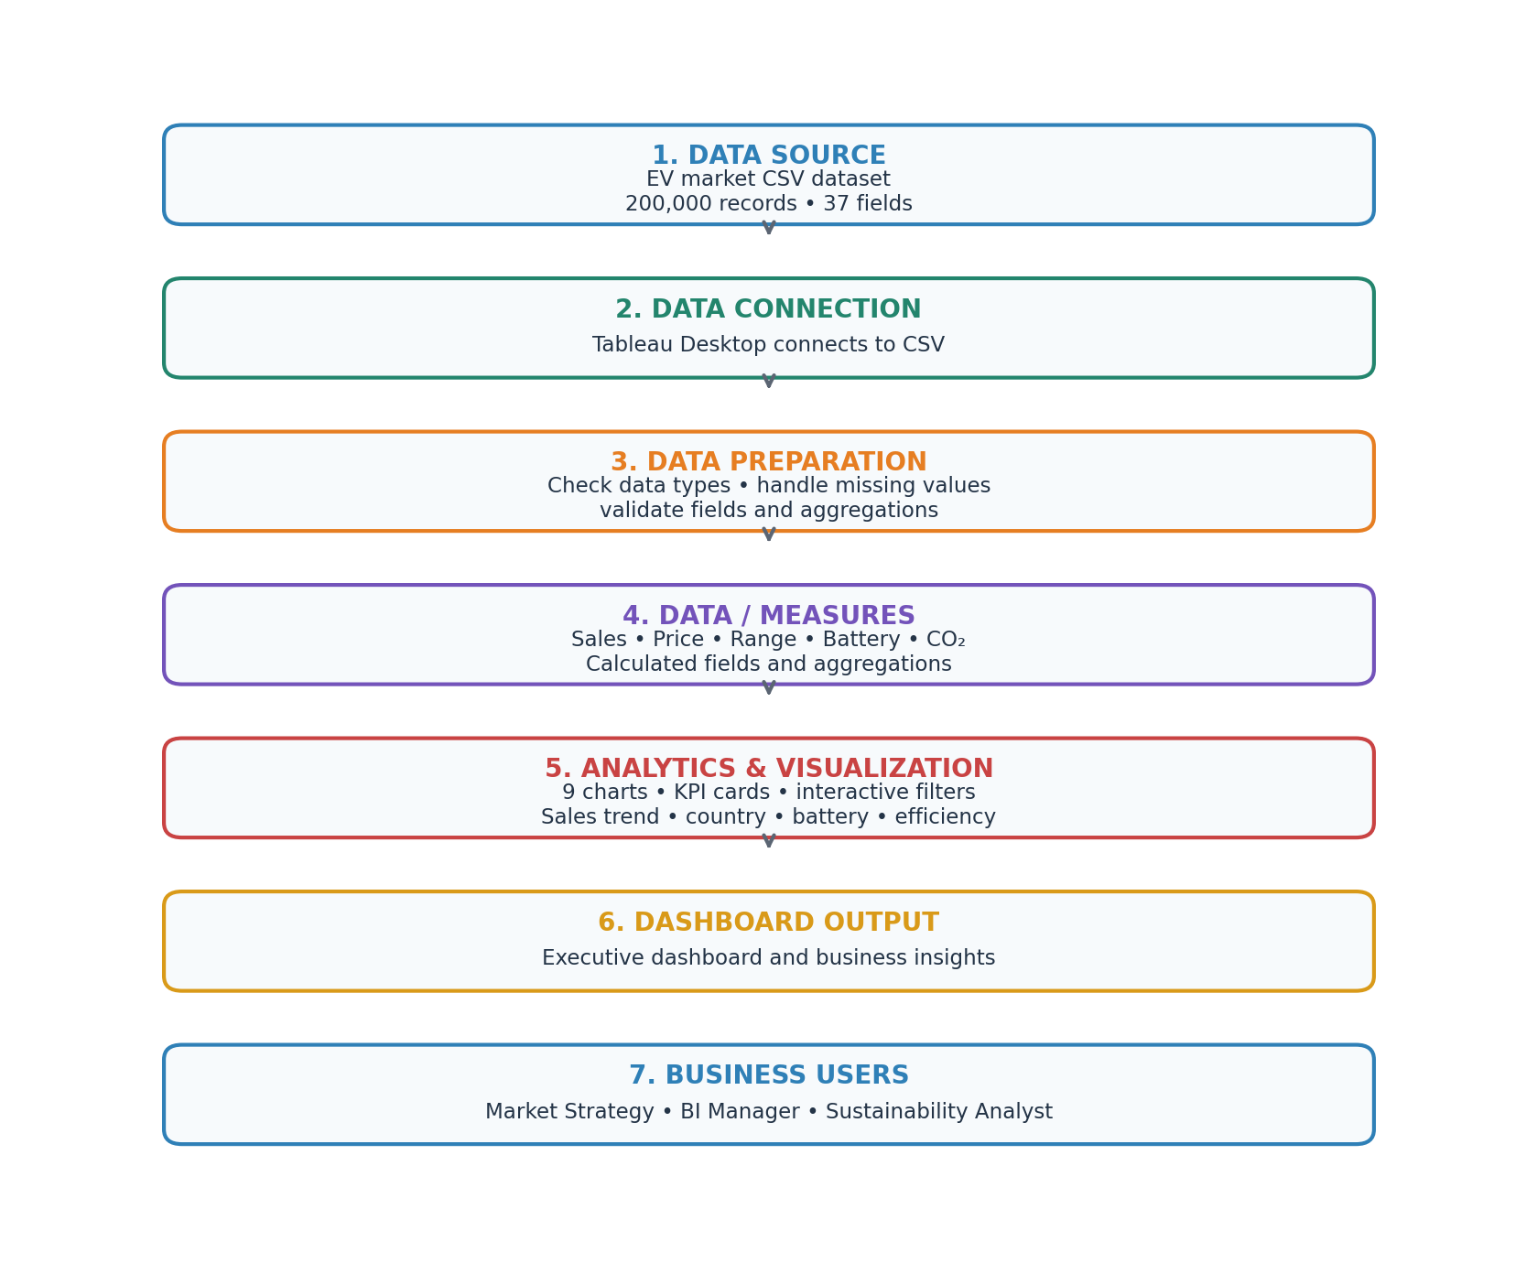
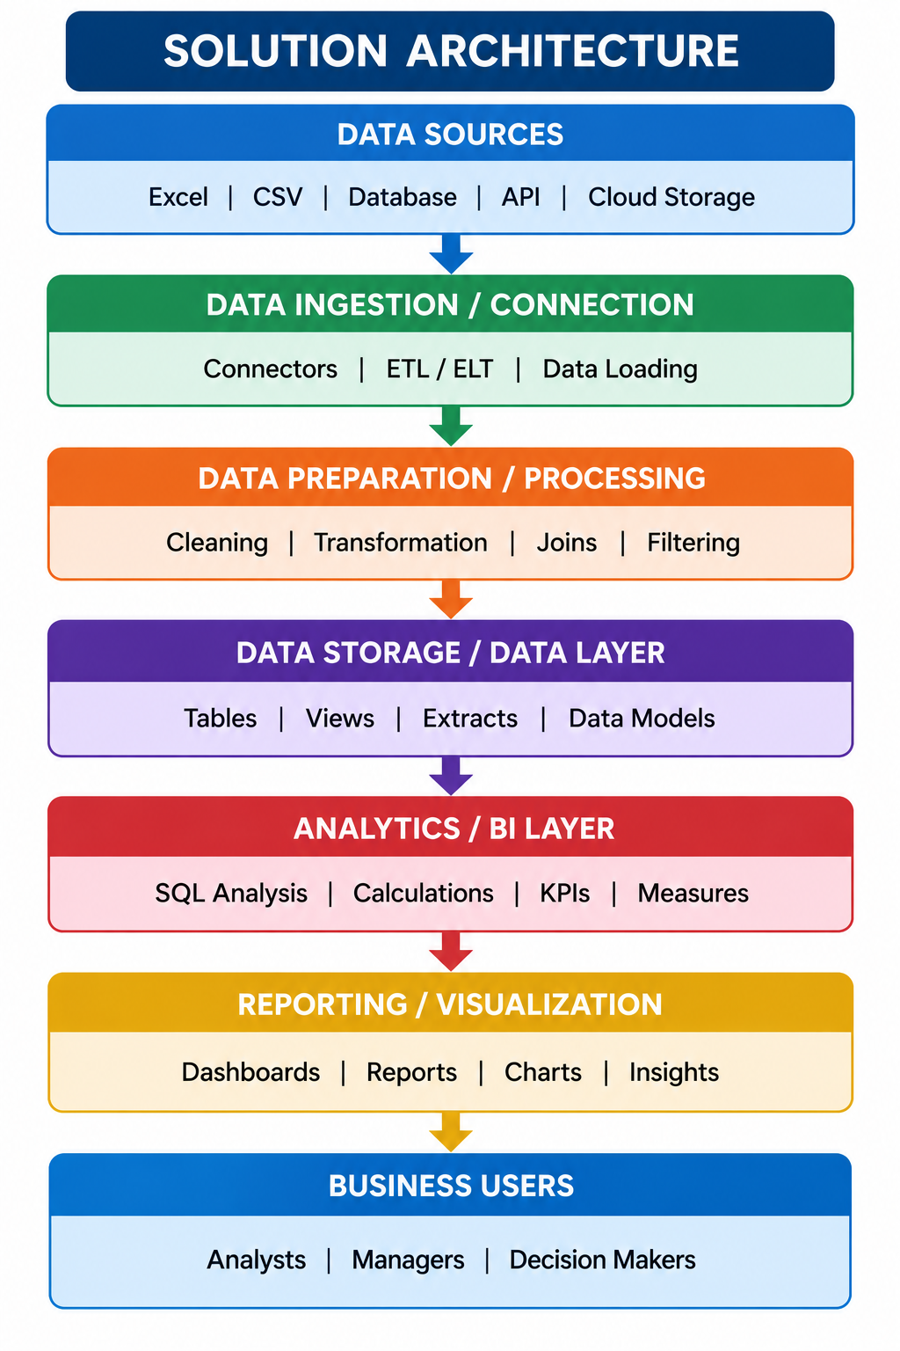

Component Description Table
Component Name | Description / Role in Architecture | Technology Used

Component Description Table
Component Name | Description / Role in Architecture | Technology Used
Data Source | Contains EV sales, manufacturer, category, battery, price, range, charging, rating and CO₂ metrics. | ev_market_train.csv
Data Connection & Preparation | Connects the CSV and checks field types, missing values and data quality before analysis. | Tableau Desktop – Data Source
Analytics & Measures | Calculates aggregated sales, average price, average range, CO₂ savings and other metrics. | Tableau calculated fields and aggregations
Visualization & Dashboard | Combines nine visualizations, KPI cards, filters, tooltips and selection actions into an interactive dashboard. | Tableau Desktop / Tableau Public
Business Users | Enables market strategy, business intelligence and sustainability users to explore trends and compare segments. | Interactive Tableau dashboard

